**HTML Tutorial: Ids & Classes in HTML | Web Development Tutorials #10**

**HTML Tutorial- IDs and Classes in HTML**

Here, we are going to learn about **IDs**and **Classes**in HTML. The [ID](https://developer.mozilla.org/en-US/docs/Web/HTML/Global_attributes/id) is an identifier which must be unique in the whole HTML document. It is used to find an element while linking, scripting, or styling. Whereas, [Classes](https://developer.mozilla.org/en-US/docs/Web/HTML/Global_attributes/class) allow CSS and JavaScript to select and access specific elements. Let us start by making a new file as *tut10.html*and adding an instant boilerplate to get the basic HTML template. Name the <title> tag as **Ids and Classes in HTML**to give the title of the website.

Here, I'll try to explain with the vert basic example. When a new child is born, we urge to give him a name or his identity by which he will be known further. Or if you are having a pet, you must have given him some name to call. In the same way, IDs refer to giving a name to any particular element for its identity. It simply refers giving an identity to an element. We know, no two names can be given to any of the two members of the family. In the same way, one ID can be given to only one element on a website. Therefore, in the below example, the id ***mainBox***cannot be given to any other element.

<div id= “mainBox” class= “redBG”>

Copy

Now the question arises what is the need for an ID in HTML? The answer is, while using JavaScript or CSS, we can target one full element and can make the necessary changes in it. In the same way, we can grab the full element and change the border or width or many more things through CSS.

Let us now understand what are classes with an example. Assume that I am having 100 elements in my HTML and I want to give a red background to all the 100 elements. To do this, we have two options. Either we have to select each element and assign a red background to it or we can create a class ***redBG***and assign a red background to it. Then we can give this class to the elements in which we want a red background color. To avoid confusion, I am assuming that the class redBG is already defined.

One point to note here is we can assign only one ID to a particular element but it is not so in the case of classes. An element can have more than one class in itself. The more classes we add in an element, the more property will get added to it.

Classes are denoted by a dot ‘.’ and ID is denoted by hash ‘#’. For example, to get a redBG class in an element we can simply write that element name followed by .redBG. The below picture shows everything, you have learned till now-

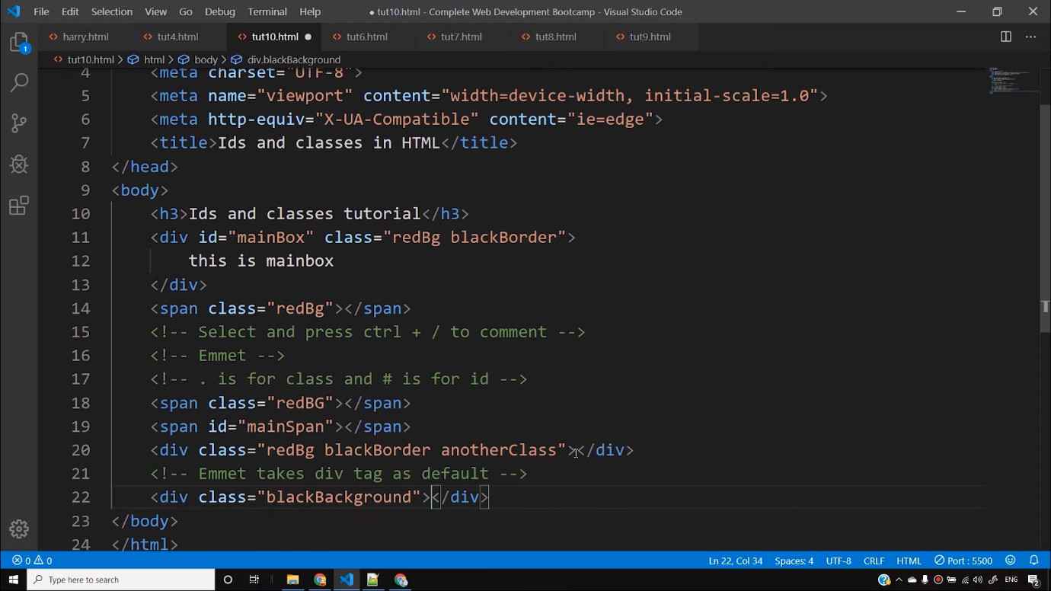

These are the major differences between classes and IDs. You can take the help of the references provided and practice more to understand more about them. However, we will learn more in detail about them in CSS and JavaScripts.

**Code as described/written in the video**

<!DOCTYPE html>

<html lang="en">

<head>

<meta charset="UTF-8">

<meta name="viewport" content="width=device-width, initial-scale=1.0">

<meta http-equiv="X-UA-Compatible" content="ie=edge">

<title>Ids and classes in HTML</title>

</head>

<body>

<h3>Ids and classes tutorial</h3>

<div id="mainBox" class="redBg blackBorder">

this is mainbox

</div>

<span class="redBg"></span>

<!-- Select and press ctrl + / to comment -->

<!-- Emmet -->

<!-- . is for class and # is for id -->

<span class="redBg"></span>

<span id="mainSpan"></span>

<div class="redBg blackBorder anotherClass"></div>

<!-- Emmet takes div tag as default -->

<div class="blackBackground"></div>

<!-- Creating multiple elements using Emmet -->

<!-- span.myClass.myClass2.myClass3*4 + <Tab> to print 4 similar elements using Emmet -->

<span class="myClass myClass2 myClass3">First</span>

<span class="myClass myClass2 myClass3">Second</span>

<span class="myClass myClass2 myClass3">Third</span>

<span class="myClass myClass2 myClass3">Fourth</span>

</body>

</html>

# HTML class Attribute

[❮ Previous](https://www.w3schools.com/html/html_blocks.asp)[Next ❯](https://www.w3schools.com/html/html_id.asp)

The HTML class attribute is used to specify a class for an HTML element.

Multiple HTML elements can share the same class.

## **Using The class Attribute**

The class attribute is often used to point to a class name in a style sheet. It can also be used by a JavaScript to access and manipulate elements with the specific class name.

In the following example we have three <div> elements with a class attribute with the value of "city". All of the three <div> elements will be styled equally according to the .city style definition in the head section:

### **Example**

<!DOCTYPE html>  
<html>  
<head>  
<style>  
.city {  
  background-color: tomato;  
  color: white;  
  border: 2px solid black;  
  margin: 20px;  
  padding: 20px;  
}  
</style>  
</head>  
<body>  
  
<div class="city">  
  <h2>London</h2>  
  <p>London is the capital of England.</p>  
</div>  
  
<div class="city">  
  <h2>Paris</h2>  
  <p>Paris is the capital of France.</p>  
</div>  
  
<div class="city">  
  <h2>Tokyo</h2>  
  <p>Tokyo is the capital of Japan.</p>  
</div>  
  
</body>  
</html>

[Try it Yourself »](https://www.w3schools.com/html/tryit.asp?filename=tryhtml_classes_capitals)

In the following example we have two <span> elements with a class attribute with the value of "note". Both <span> elements will be styled equally according to the .note style definition in the head section:

### **Example**

<!DOCTYPE html>  
<html>  
<head>  
<style>  
.note {  
  font-size: 120%;  
  color: red;  
}  
</style>  
</head>  
<body>  
  
<h1>My <span class="note">Important</span> Heading</h1>  
<p>This is some <span class="note">important</span> text.</p>  
  
</body>  
</html>

[Try it Yourself »](https://www.w3schools.com/html/tryit.asp?filename=tryhtml_classes_span)

**Tip:** The class attribute can be used on **any** HTML element.

**Note:** The class name is case sensitive!

**Tip:** You can learn much more about CSS in our [CSS Tutorial](https://www.w3schools.com/css/default.asp).

ADVERTISEMENT

## **The Syntax For Class**

To create a class; write a period (.) character, followed by a class name. Then, define the CSS properties within curly braces {}:

### **Example**

Create a class named "city":

<!DOCTYPE html>  
<html>  
<head>  
<style>  
.city {  
  background-color: tomato;  
  color: white;  
  padding: 10px;  
}  
</style>  
</head>  
<body>  
  
<h2 class="city">London</h2>  
<p>London is the capital of England.</p>  
  
<h2 class="city">Paris</h2>  
<p>Paris is the capital of France.</p>  
  
<h2 class="city">Tokyo</h2>  
<p>Tokyo is the capital of Japan.</p>  
  
</body>  
</html>

[Try it Yourself »](https://www.w3schools.com/html/tryit.asp?filename=tryhtml_classes_css)

## **Multiple Classes**

HTML elements can belong to more than one class.

To define multiple classes, separate the class names with a space, e.g. <div class="city main">. The element will be styled according to all the classes specified.

In the following example, the first <h2> element belongs to both the city class and also to the main class, and will get the CSS styles from both of the classes:

### **Example**

<h2 class="city main">London</h2>  
<h2 class="city">Paris</h2>  
<h2 class="city">Tokyo</h2>

[Try it Yourself »](https://www.w3schools.com/html/tryit.asp?filename=tryhtml_classes_multiple)

## **Different Elements Can Share Same Class**

Different HTML elements can point to the same class name.

In the following example, both <h2> and <p> points to the "city" class and will share the same style:

### **Example**

<h2 class="city">Paris</h2>  
<p class="city">Paris is the capital of France</p>

[Try it Yourself »](https://www.w3schools.com/html/tryit.asp?filename=tryhtml_classes_tags)

## **Use of The class Attribute in JavaScript**

The class name can also be used by JavaScript to perform certain tasks for specific elements.

JavaScript can access elements with a specific class name with the getElementsByClassName() method:

### **Example**

Click on a button to hide all elements with the class name "city":

<script>  
function myFunction() {  
  var x = **document.getElementsByClassName("city")**;  
  for (var i = 0; i < x.length; i++) {  
    x[i].style.display = "none";  
  }  
}  
</script>

# HTML id Attribute

[❮ Previous](https://www.w3schools.com/html/html_classes.asp)[Next ❯](https://www.w3schools.com/html/html_iframe.asp)

The HTML id attribute is used to specify a unique id for an HTML element.

You cannot have more than one element with the same id in an HTML document.

## **Using The id Attribute**

The id attribute specifies a unique id for an HTML element. The value of the id attribute must be unique within the HTML document.

The id attribute is used to point to a specific style declaration in a style sheet. It is also used by JavaScript to access and manipulate the element with the specific id.

The syntax for id is: write a hash character (#), followed by an id name. Then, define the CSS properties within curly braces {}.

In the following example we have an <h1> element that points to the id name "myHeader". This <h1> element will be styled according to the #myHeader style definition in the head section:

### **Example**

<!DOCTYPE html>  
<html>  
<head>  
<style>  
#myHeader {  
  background-color: lightblue;  
  color: black;  
  padding: 40px;  
  text-align: center;  
}  
</style>  
</head>  
<body>  
  
<h1 id="myHeader">My Header</h1>  
  
</body>  
</html>

[Try it Yourself »](https://www.w3schools.com/html/tryit.asp?filename=tryhtml_id_css)

**Note:** The id name is case sensitive!

**Note:** The id name must contain at least one character, cannot start with a number, and must not contain whitespaces (spaces, tabs, etc.).

## **Difference Between Class and ID**

A class name can be used by multiple HTML elements, while an id name must only be used by one HTML element within the page:

### **Example**

<style>  
/* Style the element with the id "myHeader" */  
**#myHeader** {  
  background-color: lightblue;  
  color: black;  
  padding: 40px;  
  text-align: center;  
}  
  
/* Style all elements with the class name "city" */  
**.city**{  
  background-color: tomato;  
  color: white;  
  padding: 10px;  
}  
</style>  
  
<!-- An element with a unique id -->  
<h1 id="myHeader">My Cities</h1>  
  
<!-- Multiple elements with same class -->  
<h2 class="city">London</h2>  
<p>London is the capital of England.</p>  
  
<h2 class="city">Paris</h2>  
<p>Paris is the capital of France.</p>  
  
<h2 class="city">Tokyo</h2>  
<p>Tokyo is the capital of Japan.</p>

[Try it Yourself »](https://www.w3schools.com/html/tryit.asp?filename=tryhtml_id_class)

**Tip:** You can learn much more about CSS in our [CSS Tutorial](https://www.w3schools.com/css/default.asp).

ADVERTISEMENT

## **HTML Bookmarks with ID and Links**

HTML bookmarks are used to allow readers to jump to specific parts of a webpage.

Bookmarks can be useful if your page is very long.

To use a bookmark, you must first create it, and then add a link to it.

Then, when the link is clicked, the page will scroll to the location with the bookmark.

## **Example**

First, create a bookmark with the id attribute:

<h2 id="C4">Chapter 4</h2>

Then, add a link to the bookmark ("Jump to Chapter 4"), from within the same page:

### **Example**

<a href="#C4">Jump to Chapter 4</a>

[Try it Yourself »](https://www.w3schools.com/html/tryit.asp?filename=tryhtml_id_bookmark)

Or, add a link to the bookmark ("Jump to Chapter 4"), from another page:

<a href="html_demo.html#C4">Jump to Chapter 4</a>

## **Using The id Attribute in JavaScript**

The id attribute can also be used by JavaScript to perform some tasks for that specific element.

JavaScript can access an element with a specific id with the getElementById() method:

### **Example**

Use the id attribute to manipulate text with JavaScript:

<script>  
function displayResult() {  
  document.getElementById("myHeader").innerHTML = "Have a nice day!";  
}  
</script>

[Try it Yourself »](https://www.w3schools.com/html/tryit.asp?filename=tryhtml_id_js)

**Tip:** Study JavaScript in the [HTML JavaScript](https://www.w3schools.com/html/html_scripts.asp) chapter, or in our [JavaScript Tutorial](https://www.w3schools.com/js/default.asp).

## **Chapter Summary**

* The id attribute is used to specify a unique id for an HTML element
* The value of the id attribute must be unique within the HTML document
* The id attribute is used by CSS and JavaScript to style/select a specific element
* The value of the id attribute is case sensitive
* The id attribute is also used to create HTML bookmarks
* JavaScript can access an element with a specific id with the getElementById() method